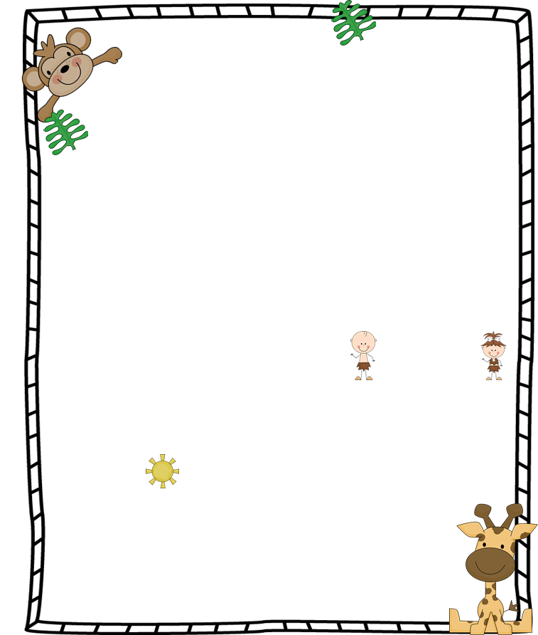

**Reading/Language Arts – Unit 1, Week 5 Objectives:**

**Comprehension skill: Author’s Purpose**

**Phonics: final blends**

**Grammar: Writing sentences**

**Phonemic Awareness: phoneme categorization**

**Spelling words (Test 10/20): land, sand, fast, past, sink, wink, flip, black, very, use**

**Challenge words: left, twist**

**High-Frequency Words (Test 10/20):**

**help, now, use, very**

**This week we will start “Word Work” (we didn’t get to it last week).**

**Math – Chapter 3, Addition Strategies**

**Religion – We will continue our study of St. Pope John Paul II**

**Writing – Adding better details to writing. Students will continue creating their own pumpkin books this month.**

**Science – Unit A, Living and Nonliving Things, quiz Thursday**

* **Our class filled the fuzzy jar for good behavior! I am so proud of them. As a reward, the children voted on bringing a stuffed animal to school this Tuesday.**
* **Please initial your child’s behavior chart every day.**
* **Please ensure your child reads “good fit books” for 15 minutes each night and record it on their reading log. Reading logs should be returned on Friday.**
* **Please quiz your child on math facts and words each night. It helps so much!**

**Miss Janowitz’s 1st Grade**

Oct. 16 – Oct. 20

**Jungle News**

**Announcements**

**Swinging into Learning**

**Queen of the Jungle**

**Monday, 10/16:**

**Scholastic orders due**

**Tuesday, 10/17:**

**Bring a stuffed animal to school day**

**Thursday, 10/19:**

**Science quiz**

**Friday, 10/20:**

**Grandparent/VIP Day**

**Spelling and HFW tests**

**Camilla**

**“Wild” Days at School**